EUDR API specifications for Operators
Conformance Test 1

Version 0.1 – dated 8th May 2024

Technical contacts:
Karine GADIOU, Karine.GADIOU@ext.ec.europa.eu
EUDR IS Team, ENV-EUDR-IS-TEAM@ec.europa.eu
Policy contact:
Gabor Lovasi, gabor.lovasi@ec.europa.eu

Contents
1 Contents 2
2 Target audience 3
3 Introduction 3
4 Prerequisites 4
5 Objectives 4
6 Tasks 5
6.1 Identification of contact points in participating teams 5
6.2 Acquiring Credentials for a Web Service User 5
6.3 Test connection to a basic Web Service of the EUDR system 7
6.4 Connection for more than one Economic Operator 8
7 Annex 9
7.1 Manual creation of an Operator and a User 9
7.2 EudrEchoService request example 9
7.3 EudrEchoService response example 9

Target audience
This document is intended to be read by Economic Operators, involved in the EU deforestation Regulation, having an IT system which manages electronically their DDS (Due Diligence Statement) and willing to develop the interconnection with the central EUDR system to submit the DDS in an automated manner. It is also intended for public institutions or private companies willing to develop software to service Economic Operators’ needs in submitting DDS to the central EUDR system.
Organizations which shall take part in that development are called “Participants” in the document.

Introduction
Systems willing to interconnect with the central EUDR system will need to pass a set of Conformance (CF) tests onto an EU hosted testing environment to be allowed to connect later to the EUDR Production environment once it is ready.
A minimum of 4 Conformance tests will be required:
- Capability of performing a basic connection with authentication,
- Capability of submitting of a DDS,
- Capability of retrieving the reference number of a previously submitted DDS,
- Capability of managing errors occurring when submitting DDS.
Additional Conformance testing are also proposed:
- Capability of amending a previously submitted DDS,
- Capability of retracting a previously submitted DDS,
- Capability of retrieving DDS from other Operators knowing the reference & verification numbers
The instance of the central EUDR system that will be used for the CF testing is hosted in the TRACES NT system and is called “ACCEPTANCE Alpha” (in short, Alpha).
It is important to note that, due to time constraints, the European Commission (EC) has drafted specifications that are not final and may still be subject to change. The participants will be informed when new versions of the specifications will be available. Also, the Alpha environment contains software that has been recently developed and may still contain issues. The Conformance test phase must then be seen as a collaborative campaign.
The scope of this first CF test covers:
- Communication between the development teams
- Establishing an authenticated connection between systems
The technical contacts at EC can be contacted for questions during the execution of the tests.

Prerequisites

This section describes the necessary expertise which shall enable the execution of this CF test. This can concern the understanding of technical documentation and/or one or several previous tests successfully completed.
Technological expertise: understanding and ability to develop SOAP web service calls.
Previous successful CF test: none.

Objectives

This section describes the goals expected to be achieved at the end of the CF test.
Primary objectives:
- The determination of the points of contact within the participant,
- Acquire credentials to access Web Service in TRACES NT,
- Call a basic Web Service to test that connection and authentication work.
Secondary objectives:
- Be able to reuse the expertise acquired during this CF test in the future Production environment,
- Understand how a software could connect to the central EUDR system and act on behalf of several Economic Operators.
At the completion of the CF test, it is expected that the participant will have acquired the skills about the authentication process, management of the response to web services calls and reuse that for dealing with later tests.

Tasks

This section enumerates each unit of work to be performed during the CF test. The description of each task includes:
- A description of the activity to be performed for the CF test,
- The nature of any dependencies between tasks

Identification of contact points in participating teams

Send an email to the EC contact points, mentioned in the first page of the document, with the members of the participating team of this test (and potentially to later tests). Provide their name, email, and role in the scope of the test.

Acquiring Credentials for a Web Service User

- Creation of an operator and a user in TRACES NT:
The participant needs to manually create the “Operator” in TRACES NT (Alpha) corresponding to the company involved in the CF test. Participants acting on behalf of other Operators should create at least 2 “operators”.
For every Operator, at least one user must also be created. That first user will be the reference (administrator) user which will be recorded as the “responsible person” in the Company every time a Web Service Call is performed to the Central EUDR system. It cannot be an anonymous or fictional account.
Instructions on how to create Operators and Users in Alpha and get them validated are provided in Section 7.1.
Note that the created user cannot belong to more than one Operator company.

- Request and get authorization for one Web Service user:

Once the Operator is created and validated, proceed to acquire a “web service user” and an authentication key:

- Get the username of the EU Login account.
To locate the username, follow the next steps:

- Go to location: https://webgate.acceptance.ec.europa.eu/tracesnt-alpha and log in (if necessary),
- Click in the top-right corner of the screen,
- In the Popup, click in “Edit Profile”,
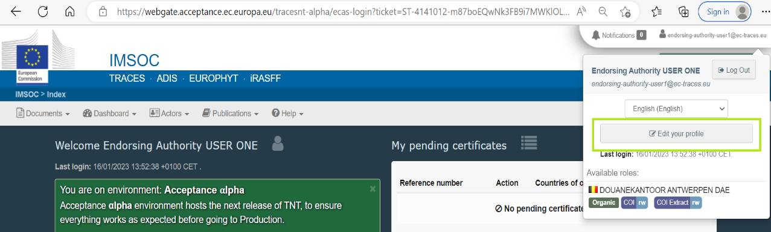

- In the right box “Personal Information” there is an attribute “username”. This value can now be used within your system for later tasks.
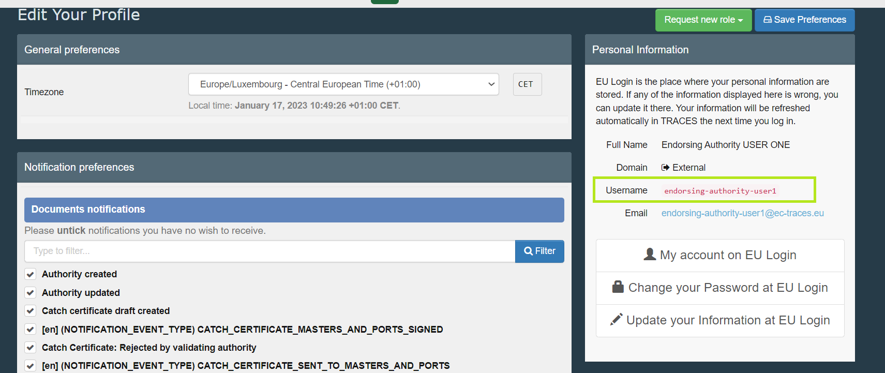

- Get the “Authentication key” for the Participant’s system:

- Go back to the page “Edit your profile” (login if necessary, as in the previous step),
- Scroll to the section “Web Services Access”,
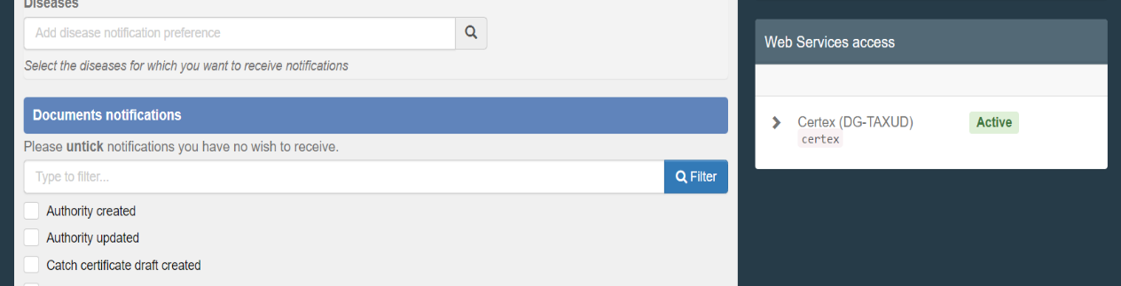

- If the previous steps have been completed successfully, the button “Active” should appear in this Section. Click on this Button. The section will contain a new field labeled “Authentication Key”. Click the “eye” next to the field to see the value. This value can now be used within the procedure described in later tasks,
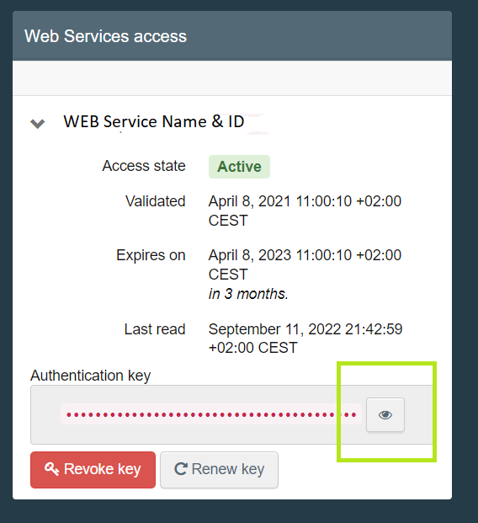

- Note that the Authentication Key is Private and should only be used with your application. The person identified by the EU Login user that was created in the first step is responsible for the data that shall be submitted into Traces NT (this is of importance when the systems will exchange production data, not in the present situation with test data in Alpha).

Test connection to a basic Web Service of the EUDR system

For this initial CF test, one basic “ping” type connection will be executed.
Necessary info for the development of the connection:
- The endpoint is the following:
https://webgate.acceptance.ec.europa.eu/tracesnt-alpha/ws/EudrEchoService

- Security:

- TRACES NT has a policy that enforces confidentiality, non-Replay and username + digest password credentials, which is described in the Wssp1.2-2007-Https-UsernameToken-Digest.xml file (read this for more details).

- The security header is formed as follows:
  - UserNameToken
    - Username – See previous sections.
    - Nonce – Random base64 number
    - Created – Creation date of the message.
    - Password – Is a digested value that is formed by the following:
      - Base64 ( SHA-1 ( nonce + created+ “Authentication Key” ) )
    - Timestamp
      - Created – Creation date of the message.

- Expires (Date) – Based on creation date, for how long this message is valid. It can’t be more than 1 minute.

- WebServiceClientId.
  - The following tag must be added in the header
    - <v4:WebServiceClientId>eudr-repository</v4:WebServiceClientId>
  - Examples of Headers containing this tag can be found in 7.2 and 7.3.

- Documentation
- WSDL and XSD Files: https://webgate.acceptance.ec.europa.eu/tracesnt-alpha/ws/EudrEchoService?wsdl

Connection for more than one Economic Operator

If the system of a participant intends to connect to the central EUDR system on behalf of many Economic Operators, it will need to get one Web Service user for each company it is acting on behalf. To do so, step 6.2 needs to be repeated for each company. The system will use the appropriate credentials to identify the company when connecting to the central system (to be used in later tests).

Annex

Manual creation of an Operator and a User

EudrEchoService request example

EudrEchoService response example

